Лабораторная работа 3

Вариант 5

Задание:

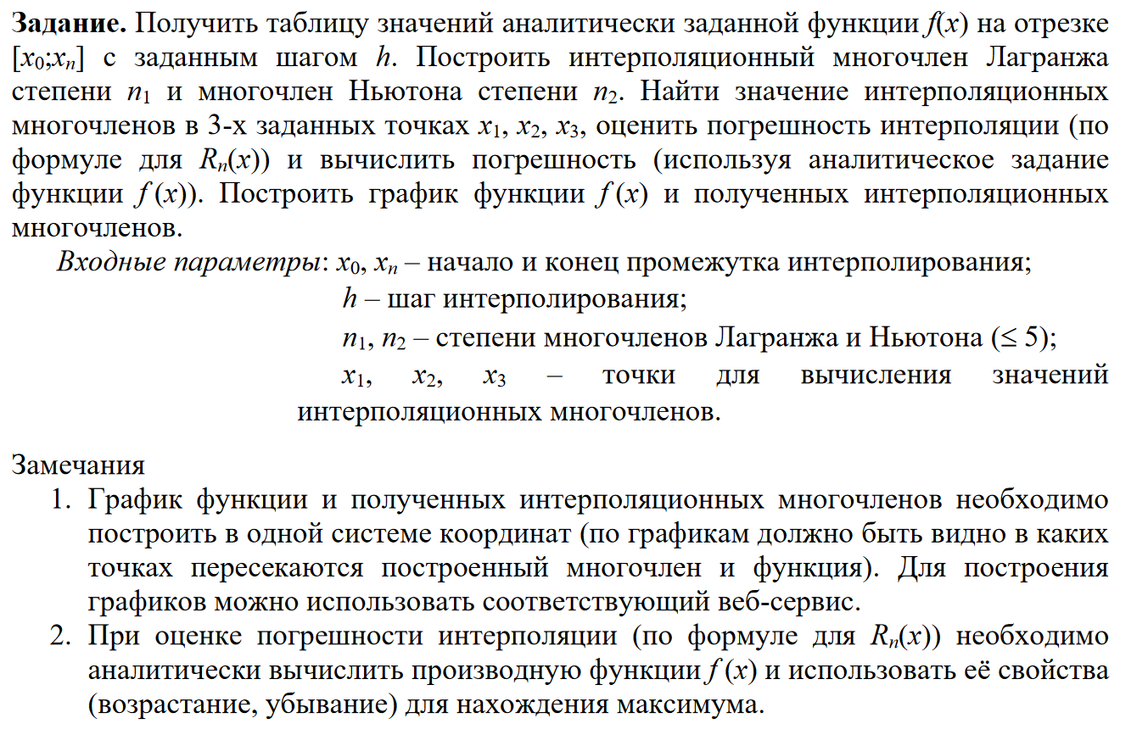



Решение:

Input a X0: 0

Input a Xn: 3,1415

Input a h: 0,6283

|  |  |  |  |  |  |  |
| --- | --- | --- | --- | --- | --- | --- |
| X | 0 | 0.6283 | 1.2566 | 1.8849 | 2.5132 | 3.1415 |
| Y(x) | 0 | 2.7458 | 5.3832 | 7.3571 | 8.6676 | 9.8694 |

Desmos

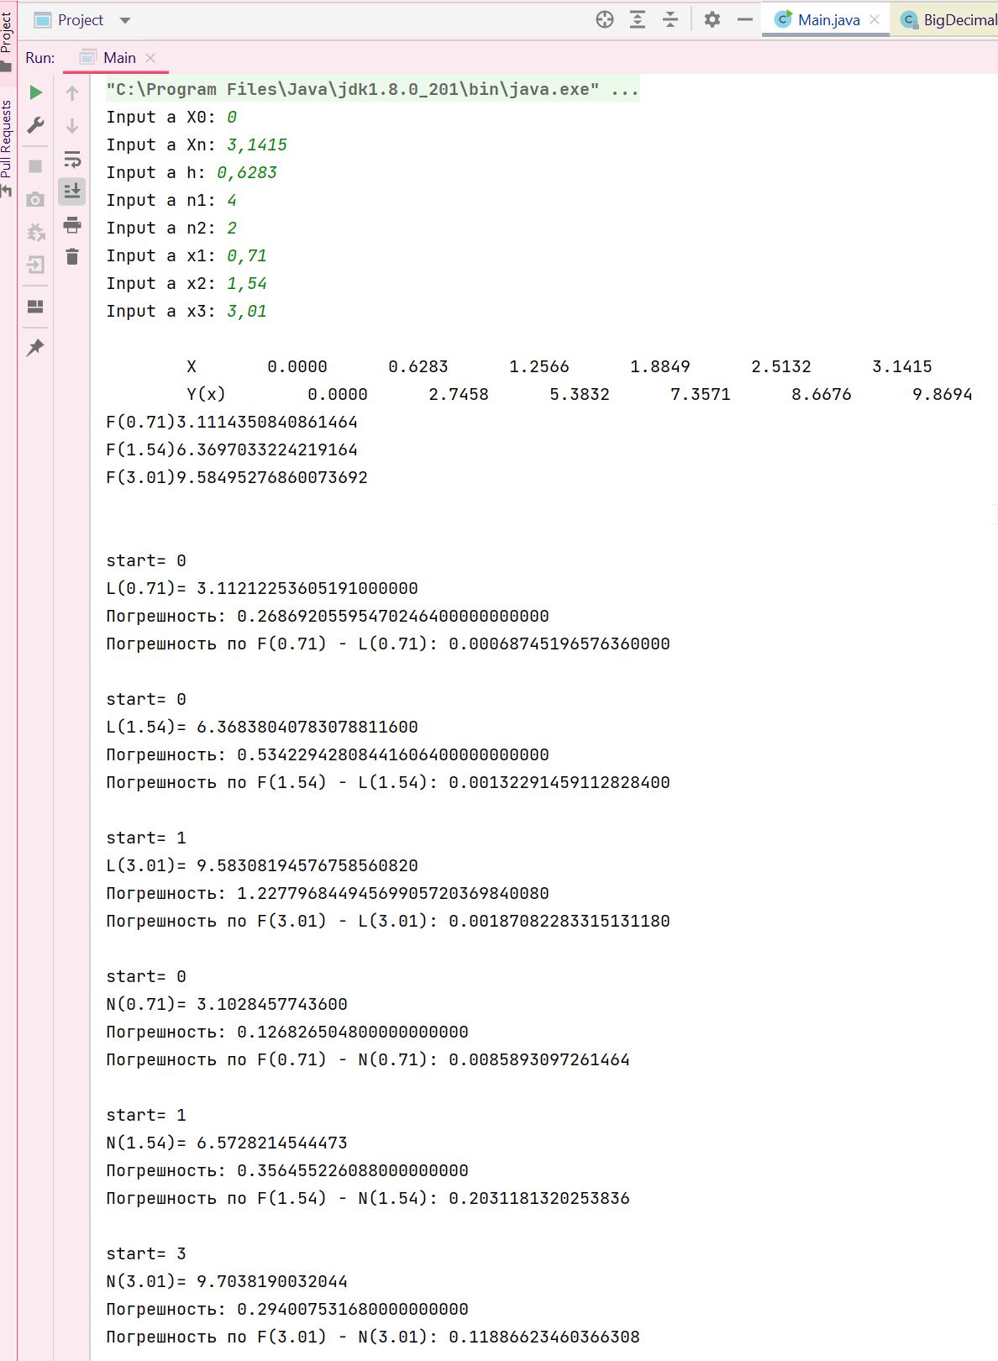 $$L_{4}\left(x\right)= y\left(x_{0}\right)\frac{\left(x-x_{1}\right)\left(x-x_{2}\right)\left(x-x_{3}\right)\left(x-x_{4}\right)}{\left(x_{0}-x_{1}\right)\left(x_{0}-x_{2}\right)\left(x_{0}-x_{3}\right)\left(x_{0}-x_{4}\right)}+y\left(x_{1}\right)\frac{\left(x-x_{0}\right)\left(x-x_{2}\right)\left(x-x_{3}\right)\left(x-x_{4}\right)}{\left(x_{1}-x_{0}\right)\left(x_{1}-x_{2}\right)\left(x_{1}-x_{3}\right)\left(x_{1}-x_{4}\right)}+y\left(x_{2}\right)\frac{\left(x-x_{0}\right)\left(x-x_{1}\right)\left(x-x_{3}\right)\left(x-x_{4}\right)}{\left(x_{2}-x_{0}\right)\left(x_{2}-x_{1}\right)\left(x_{2}-x_{3}\right)\left(x_{2}-x_{4}\right)}+y\left(x_{3}\right)\frac{\left(x-x_{0}\right)\left(x-x_{1}\right)\left(x-x_{2}\right)\left(x-x_{4}\right)}{\left(x_{3}-x_{0}\right)\left(x_{3}-x_{1}\right)\left(x_{3}-x_{2}\right)\left(x_{3}-x_{4}\right)}+y\left(x_{4}\right)\frac{\left(x-x_{0}\right)\left(x-x_{1}\right)\left(x-x_{2}\right)\left(x-x_{3}\right)}{\left(x_{4}-x_{0}\right)\left(x_{4}-x_{1}\right)\left(x_{4}-x_{2}\right)\left(x_{4}-x_{3}\right)}=0+2.7458\frac{\left(x-0\right)\left(x-1.2566\right)\left(x-1.8849\right)\left(x-2.5132\right)}{\left(0,6283-0\right)\left(0,6283-1,2566\right)\left(0,6283-1,8849\right)\left(0,6283-2,5132\right)}+5.3832\frac{\left(x-0\right)\left(x-0.6283\right)\left(x-1.8849\right)\left(x-2.5132\right)}{\left(1.2566-0\right)\left(1.2566-0.6283\right)\left(1.2566-1.8849\right)\left(1.2566-2.5132\right)}+7.3571\frac{\left(x-0\right)\left(x-0.6283\right)\left(x-1.2566\right)\left(x-2.5132\right)}{\left(1.8849-0\right)\left(1.8849-0.6283\right)\left(1.8849-1.2566\right)\left(1.8849-2.5132\right)}+8.6676\frac{\left(x-0\right)\left(x-0.6283\right)\left(x-1.2566\right)\left(x-1.8849\right)}{\left(2.5132-0\right)\left(2.5132-0.6283\right)\left(2.5132-1.2566\right)\left(2.5132-1.8849\right)}=2.7458\frac{\left(x-0\right)\left(x-1.2566\right)\left(x-1.8849\right)\left(x-2.5132\right)}{\left(-0.9350\right)}+5.3832\frac{\left(x-0\right)\left(x-0.6283\right)\left(x-1.8849\right)\left(x-2.5132\right)}{0.6233}+7.3571\frac{\left(x-0\right)\left(x-0.6283\right)\left(x-1.2566\right)\left(x-2.5132\right)}{\left(-0.9350\right)}+8.6676\frac{\left(x-0\right)\left(x-0.6283\right)\left(x-1.2566\right)\left(x-1.8849\right)}{3.7401}=2.7458\frac{\left(x^{2}-1.2566x\right)\left(x^{2}-4,3981x+4.7371\right)}{\left(-0.9350\right)}+5.3832\frac{\left(x^{2}-0,6283x\right)\left(x^{2}-4,3981x+4.7371\right)}{0.6233}+7.3571\frac{\left(x^{2}-0,6283x\right)\left(x^{2}-3,7698x+3,1581\right)}{\left(-0.9350\right)}+8.6676\frac{\left(x^{2}-0,6283x\right)\left(x^{2}-3,1415x+2,3686\right)}{3.7401}=2.7458\frac{x^{4}-5,6547x^{3}+10,2638x^{2}-5,9526x}{\left(-0.9350\right)}+5.3832\frac{x^{4}-5,0264x^{3}+9,7635x^{2}-2,9763x}{0.6233}+7.3571\frac{x^{4}-4,3981x^{3}+5,5267x^{2}-1,9842x}{\left(-0.9350\right)}+8.6676\frac{x^{4}-3,7698x^{3}+4,3424x^{2}-1,4882x}{3.7401}=-2,9367x^{4}+16,6062x^{3}-30,1417x^{2}+17,4810x+8,6366x^{4}-43,4110x^{3}+84,3234x^{2}-25,7051x-7,8686x^{4}+34,6069x^{3}-43,4874x^{2}+15,6129x+2,3175x^{4}-8,7365x^{3}+10,0635x^{2}-3,4489x=0,1488x^{4}-0,9344x^{3}+20,7578x^{2}+3,9399x$$